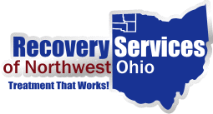

Assistance with Medication - COVID19

Health Partners of Western Ohio has expanded delivery of medications to their clients during the COVID 19 pandemic. Patients of Health Partners should contact the pharmacy at 567-239-4560 to make such arrangements.